
STEP-1
From Google chrome type in the url teacher.qb365.in
STEP-2
After this our login page will appear on the screen
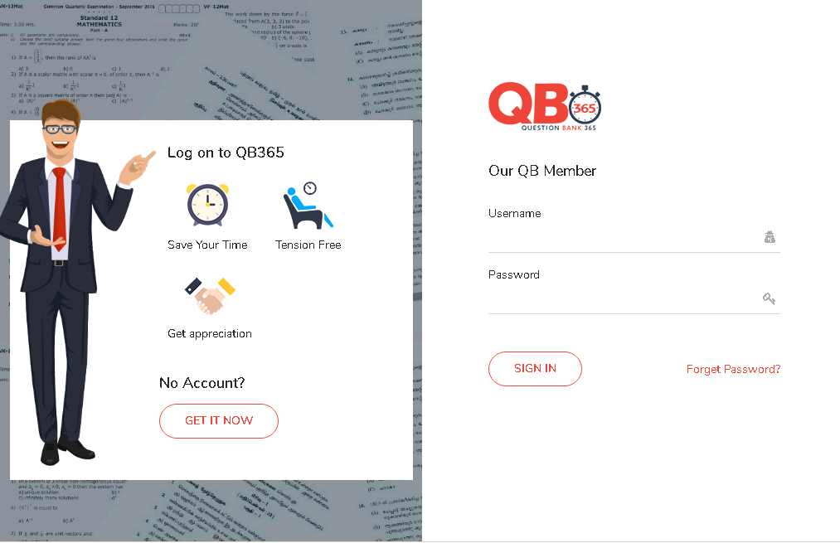

STEP-3
By using our login id and password we can sign in our software QB365
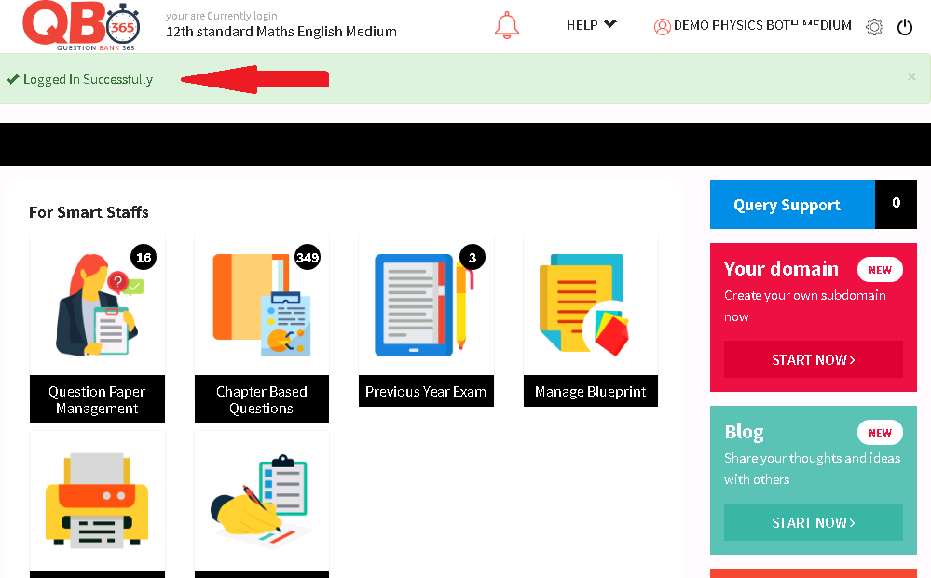
our dashboard will appear like this ( With logged in successfully)
by using this icons we can create our question paper in 5mins
In that by clicking the question paper management we can create an question paper
STEP-4

by clicking this...
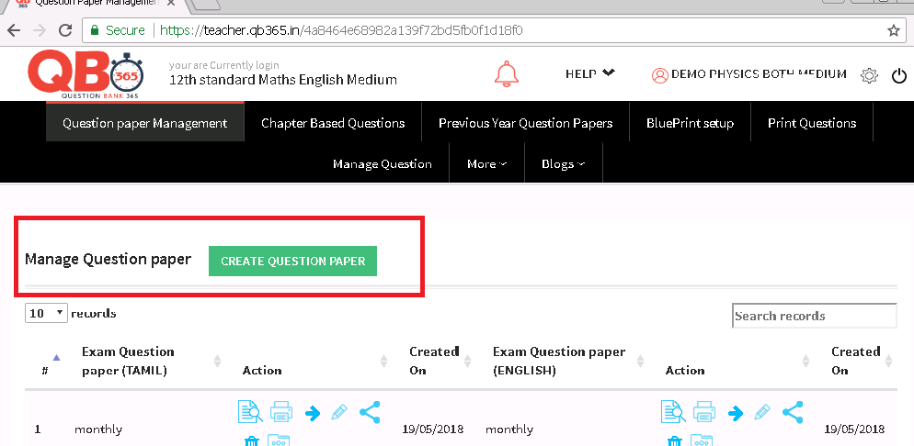
this page will appear

STEP 5
click that green icon
CREATE QUESTION PAPER

After clicking that icon the page will appear on the screen
by using the option in that page we can create an question paper easily in 5 mins
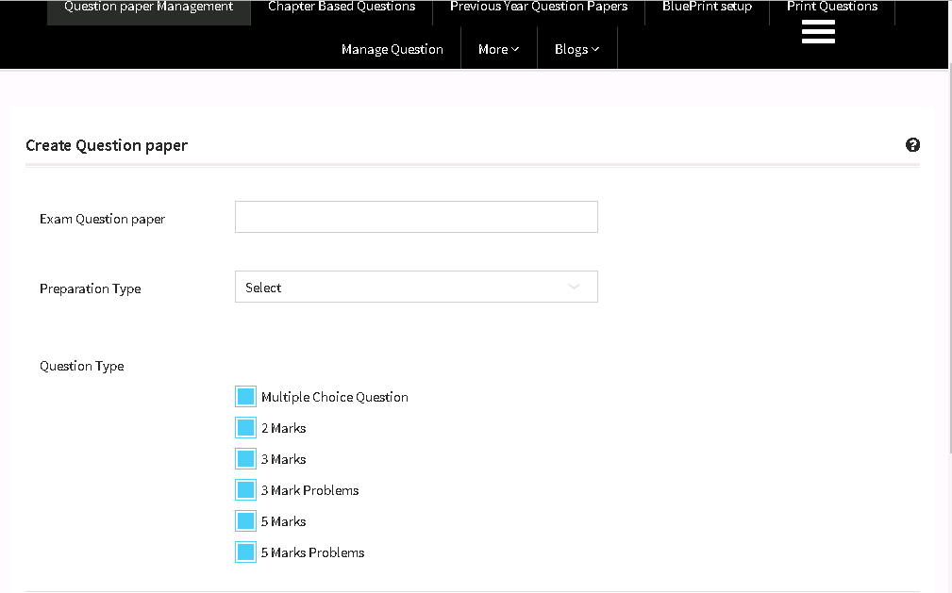
it includes
1
In this we can give the name of the exam ( like cycle-test, class-test...etc )
2
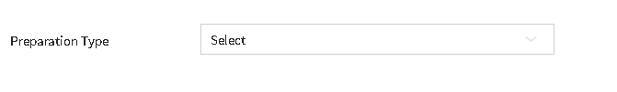in this tabular we can give the type of the exam from the drop down box
- manual - we can select the desirable questions from the in build questions
- blueprint -just by allocating a count of the questions we needed
- previous year-Past 10 years question paper already preloaded
- we can select any option to create a question paper in 5mins
3
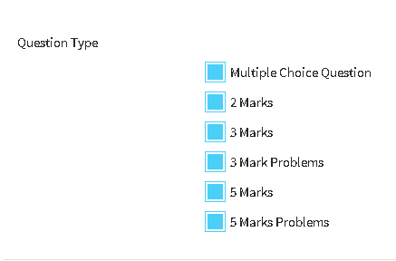 in this we can we can select the question type ( like MCQ's, 2 marks,5 marks..etc)
STEP-6
in this we can
- generate the question paper with the name of the question paper
- prepare with the type of the question paper
- and we can also select the type of the question paper

STEP-7

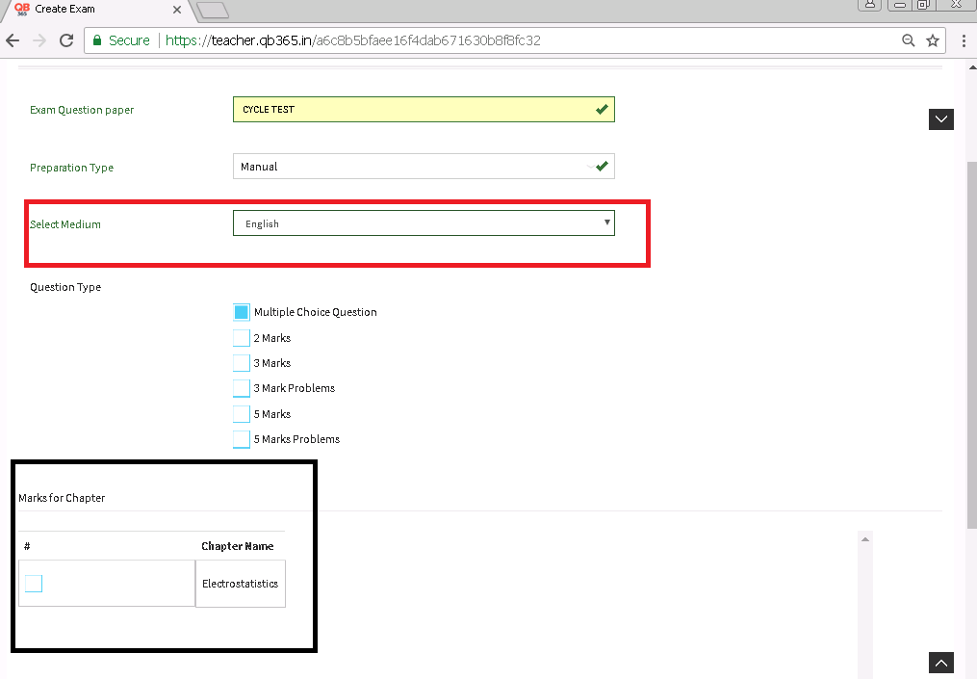After selecting the option

STEP-8
Now, we must give the details of
- medium- if suppose we purchase both medium ,this will appear on the screen ,or else it won't appear
- marks for chapter-it helps to select the chapter of the subject

after that at the bottom of the page

click GET QUESTIONS

STEP-9
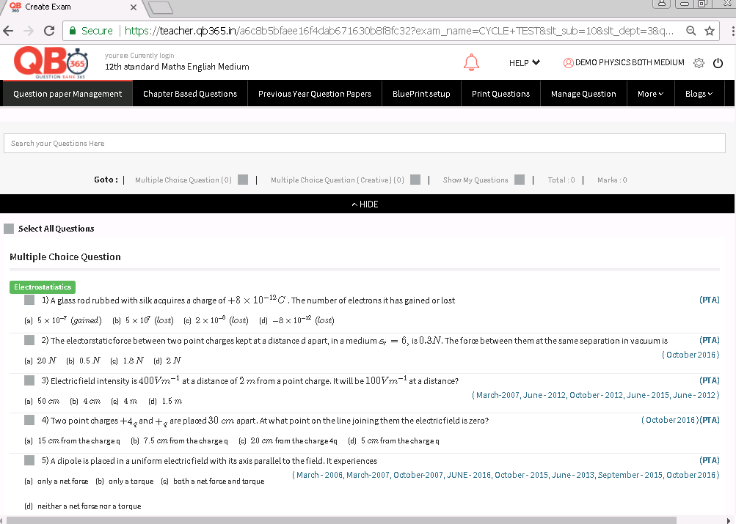
From this page we can select our questions which will have to appear in our question paper

after selecting the questions at the bottom of the page click

SHOW

STEP -10
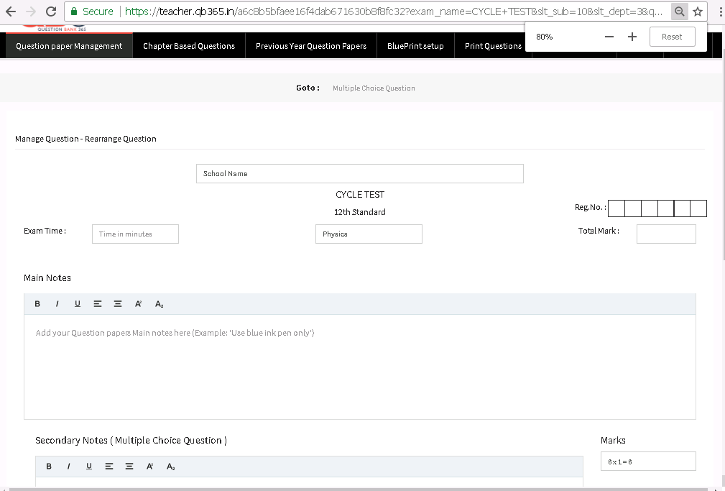
In this page we have to give the details of
- exam time - we have to give the timing in minutes
- school name- we can give our school name at top of the question paper
- reg no-students can write there reg .no
- total mark-we can allocate the total marks of the question paper
- main notes of the question paper - like avoid mal practice, use black and blue pen only
- sub-notes - like part-A,part-B..etc

after that at the bottom of the page click SAVE EXAM

STEP-11
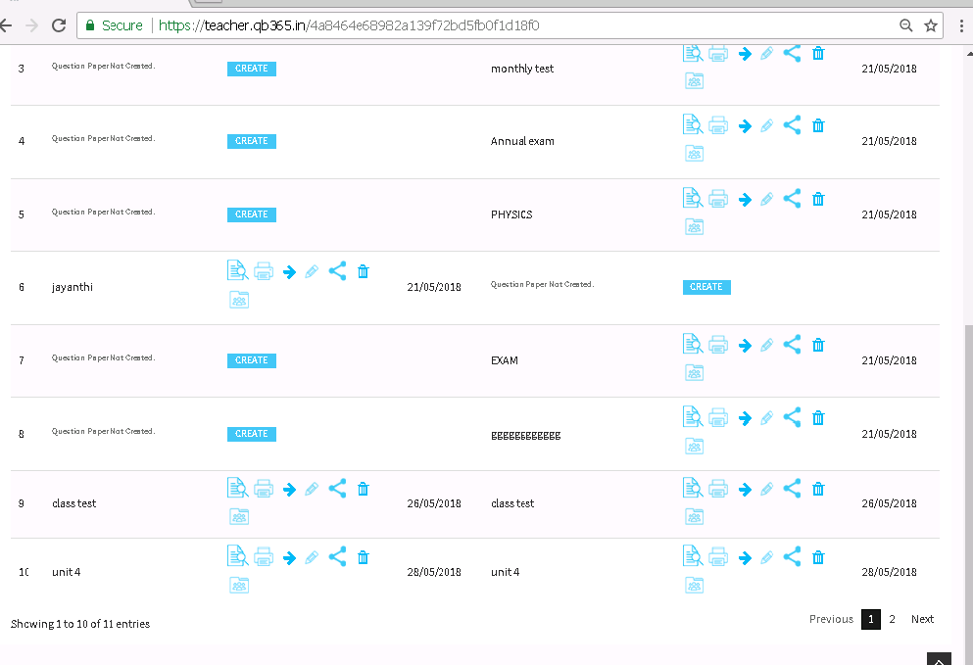
NOW, Our question paper will be saved at the end of the page with our given name of the question paper

STEP-12
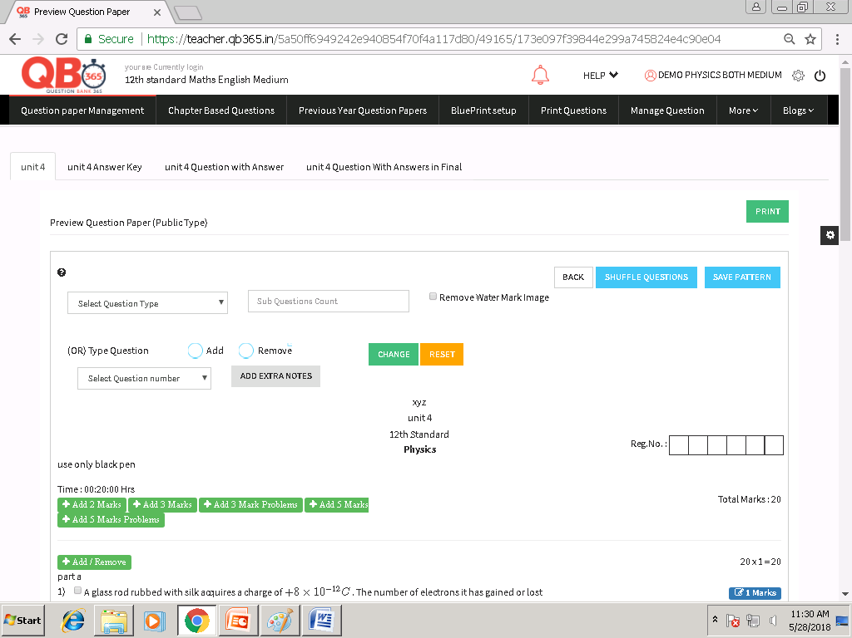
From this page we can edit our question paper before giving into print option
with
- sub section
it helps to merge two questions into one.
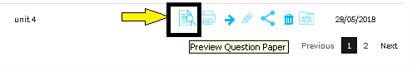
by clicking this icon our question paper will be appear on the screen
in that we can add the sub section
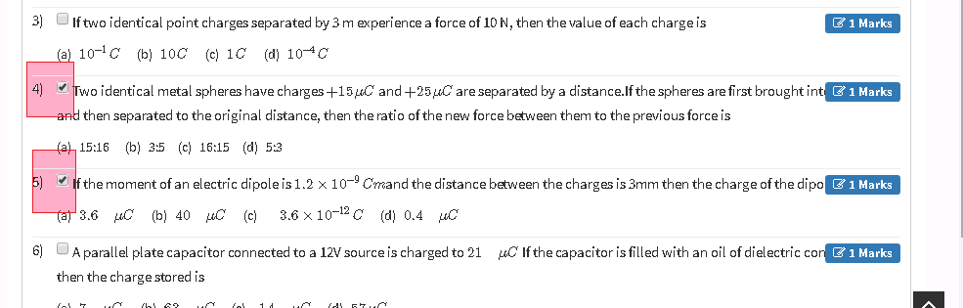
select any two question , which want to be given as an sub-section form in our question paper
after selecting the questions
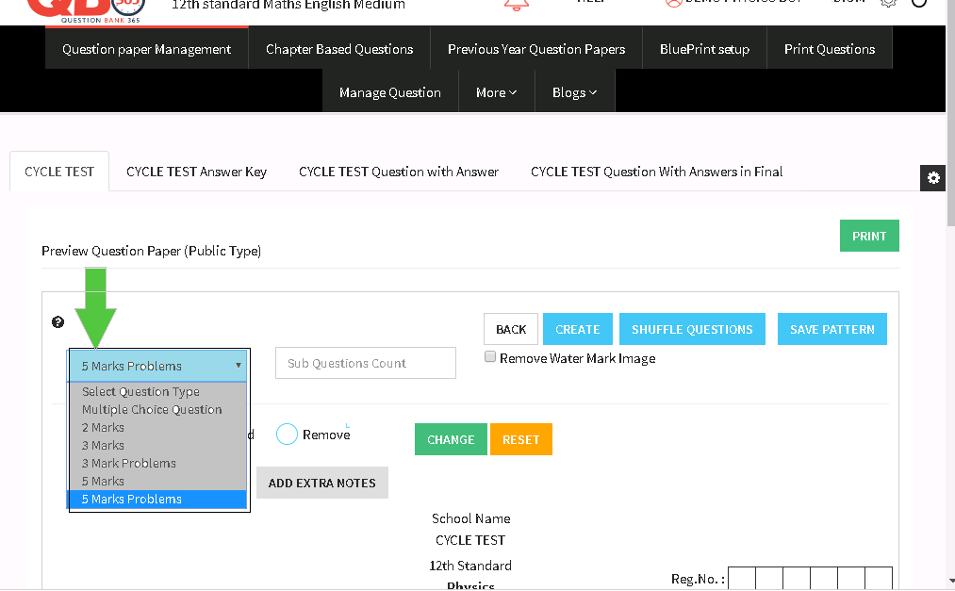
marks can be allocated for the selected questions from the drop down box ( like 2 mark, 5 mark...)
now give the question count 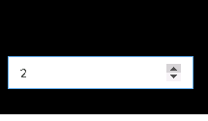 in the sub question count
after that click change icon in the top of the page
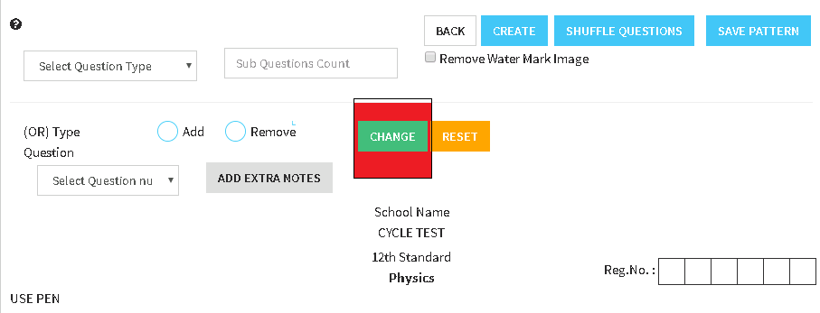
now the question will changed into sub-section form like this
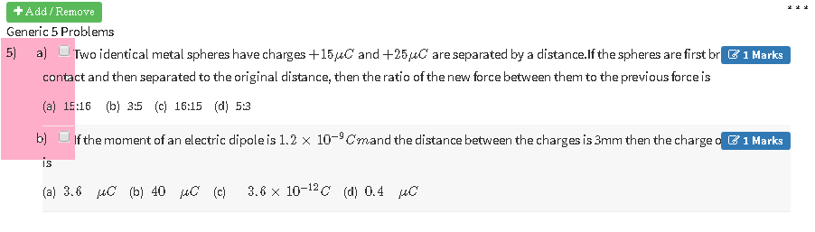
- or type questions- it helps to give the choice in between two questions
by clicking this icon our question paper will be appear on the screen
select any two question , for which OR option to be given in the question paper

click ADD option
and click CHANGE icon in the top of the page
now the question will be displayed in that form
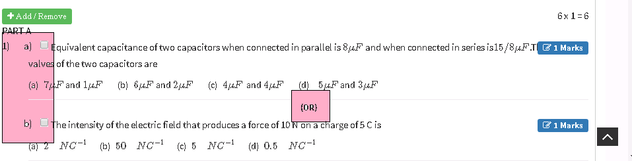

- we can also add or remove the given questions

by clicking this icon our question paper will be appear on the screen
+ADD/REMOVE
To ADD / REMOVE a questions :
- Select the ADD/REMOVE option which appears above the question part.
Now , select the questions which is to be added/ removed
To ADD / REMOVE a questions :
- Select the ADD/REMOVE option which appears above the question part.
- Now , select the questions which is to be added/ removed.
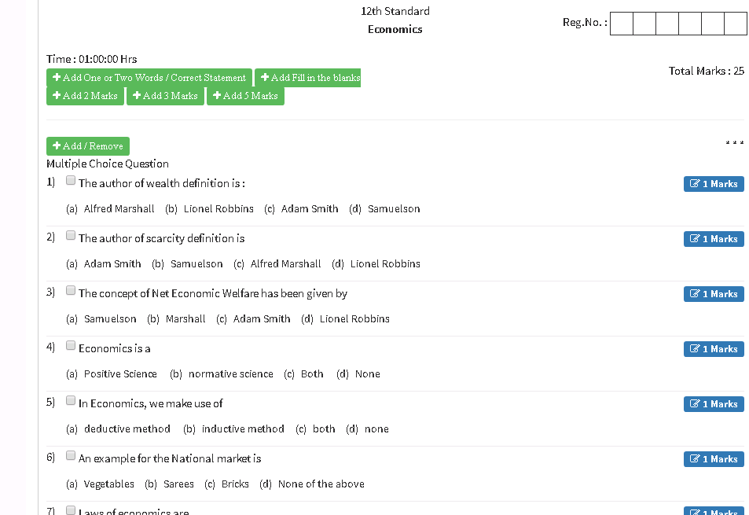

ADD EXTRA NOTES:
- Enter the question number for which the extra notes to be added.
- Now a main notes box will be displayed and where we can add the notes.

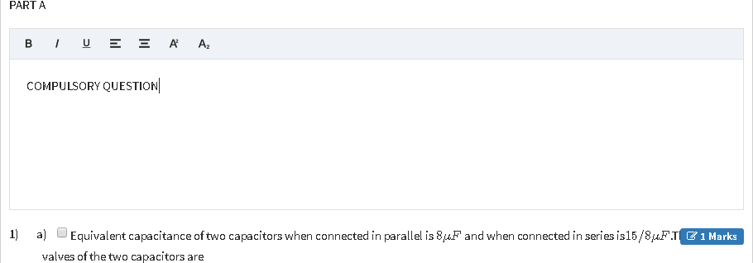

at the top right corner of the page click PRINT

Now our question paper will be generated

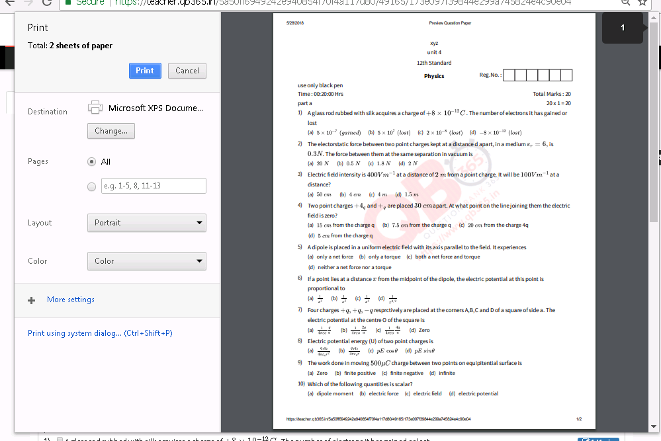
now our prepared question paper is ready to print

